* **What is an application?**

Deploying applications on 100’s

How to configure 100’s production servers?

* Devops: Ansible : 4 weeks

1)Create AWS account

2)how to create servers

3)how to execute Linux commands

4) What is Configuration Management ?

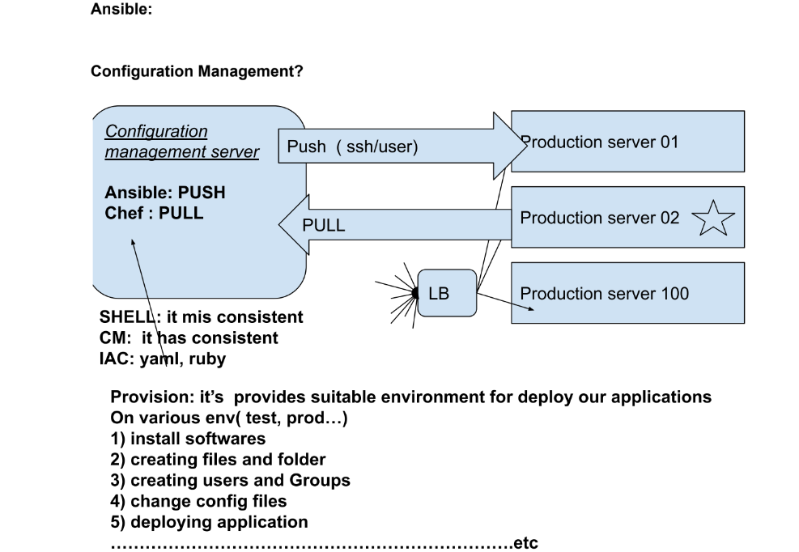

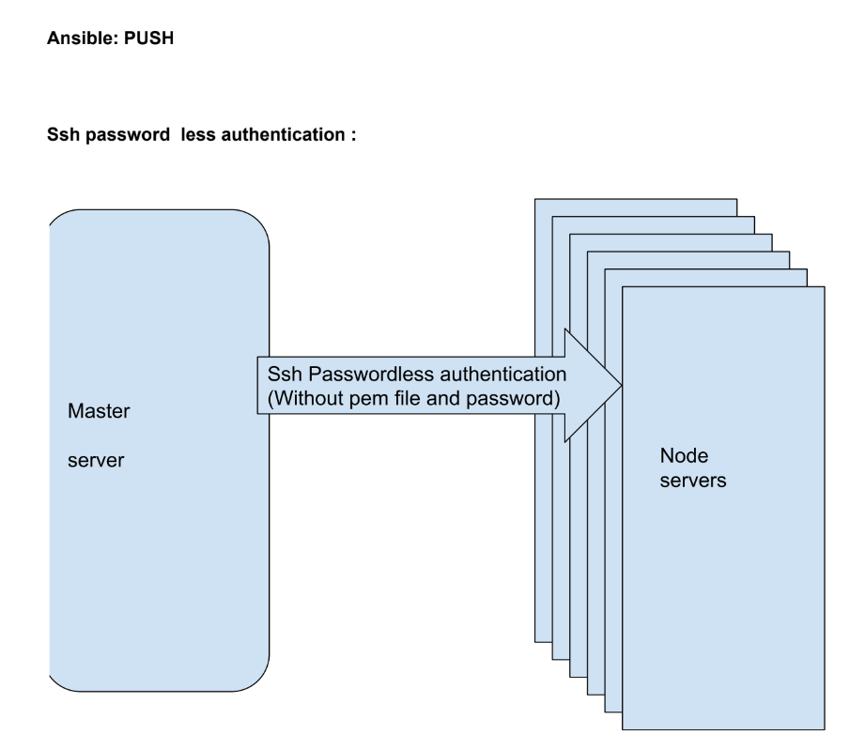

* **CONFIGURE MASTER SERVER**

1) Create an aws server with ubuntu 20. With t2.micro

2) By using git bash and pem file we can getting into server

3) $ sudo -i

4) # apt-get update

5) # adduser maha

6) # visudo

maha ALL=(ALL) NOPASSWD: ALL

Ctr+x, press y , press enter

7) # vi /etc/ssh/sshd_config( without pem , with passwd)

Passwordauthentication yes

:wq!

8) # service ssh restart

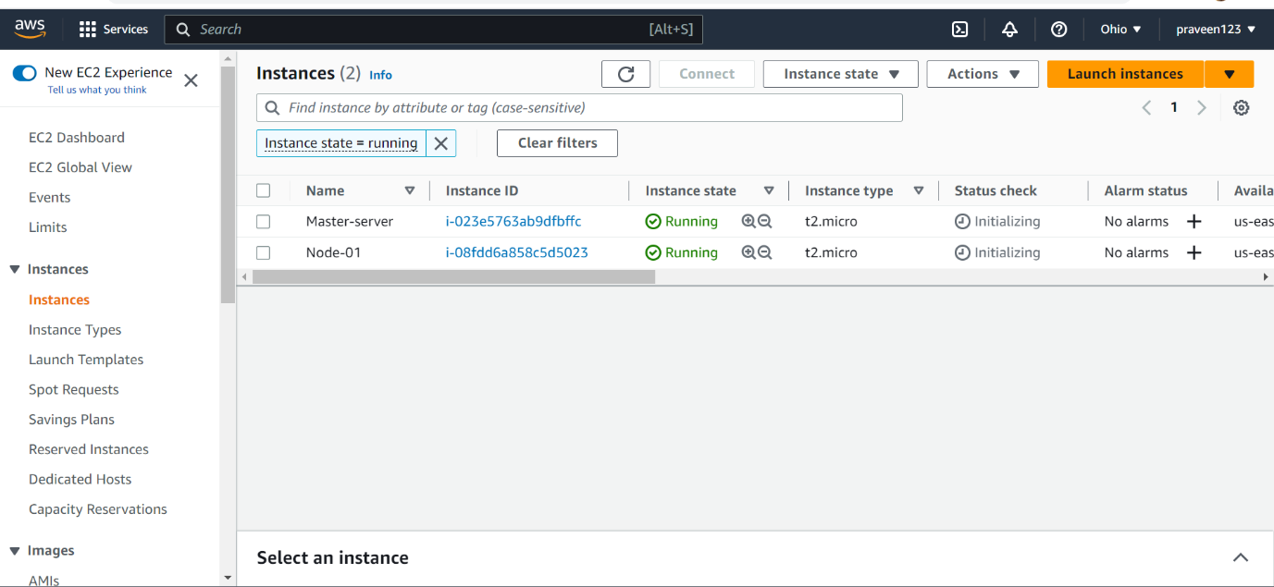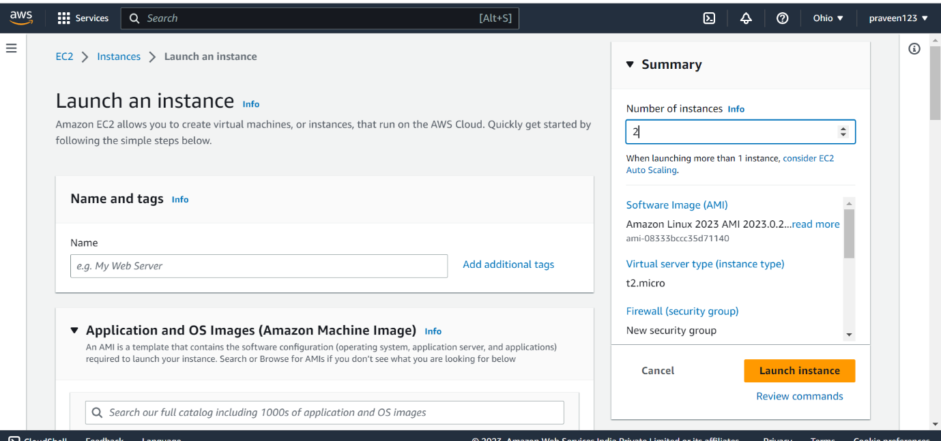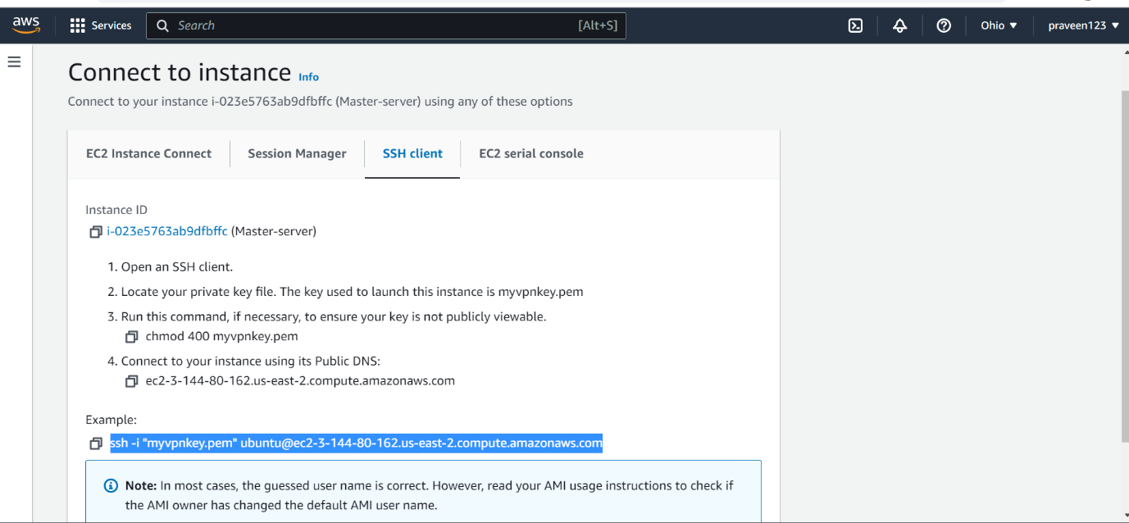

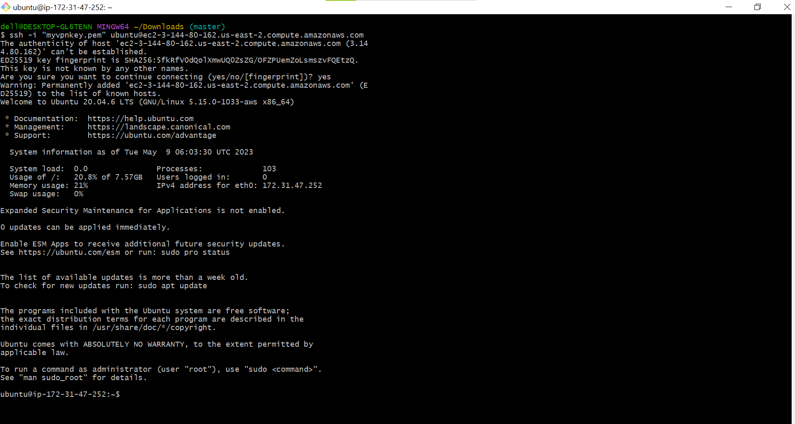

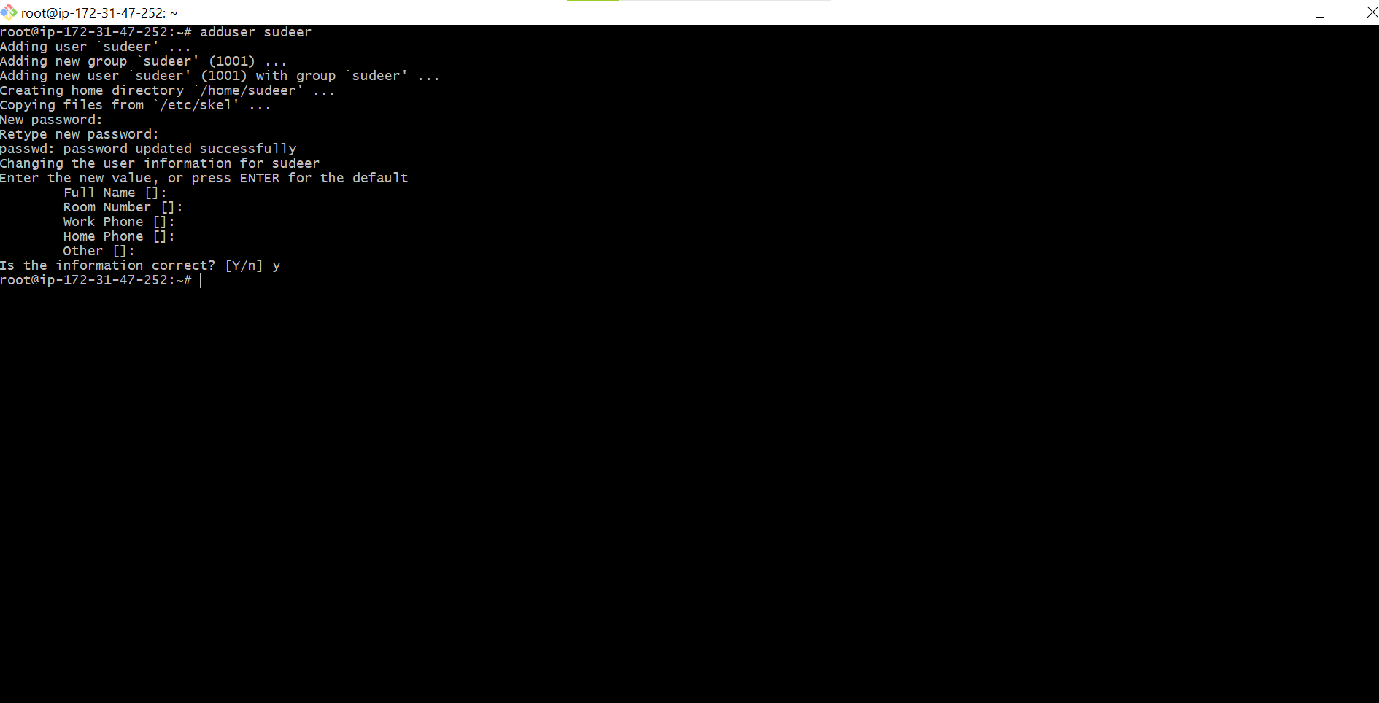

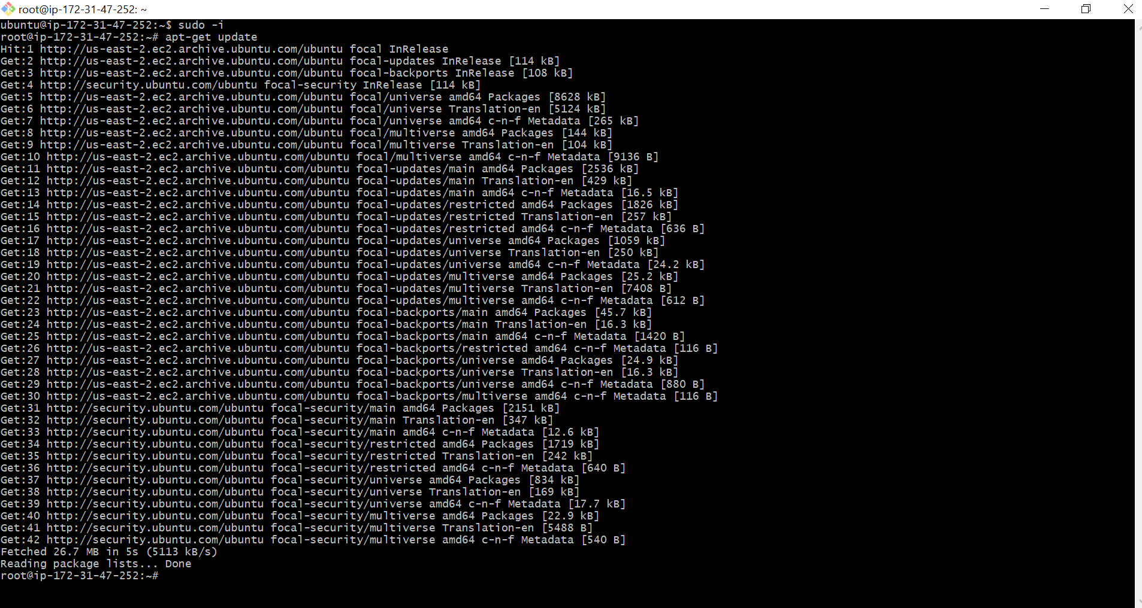

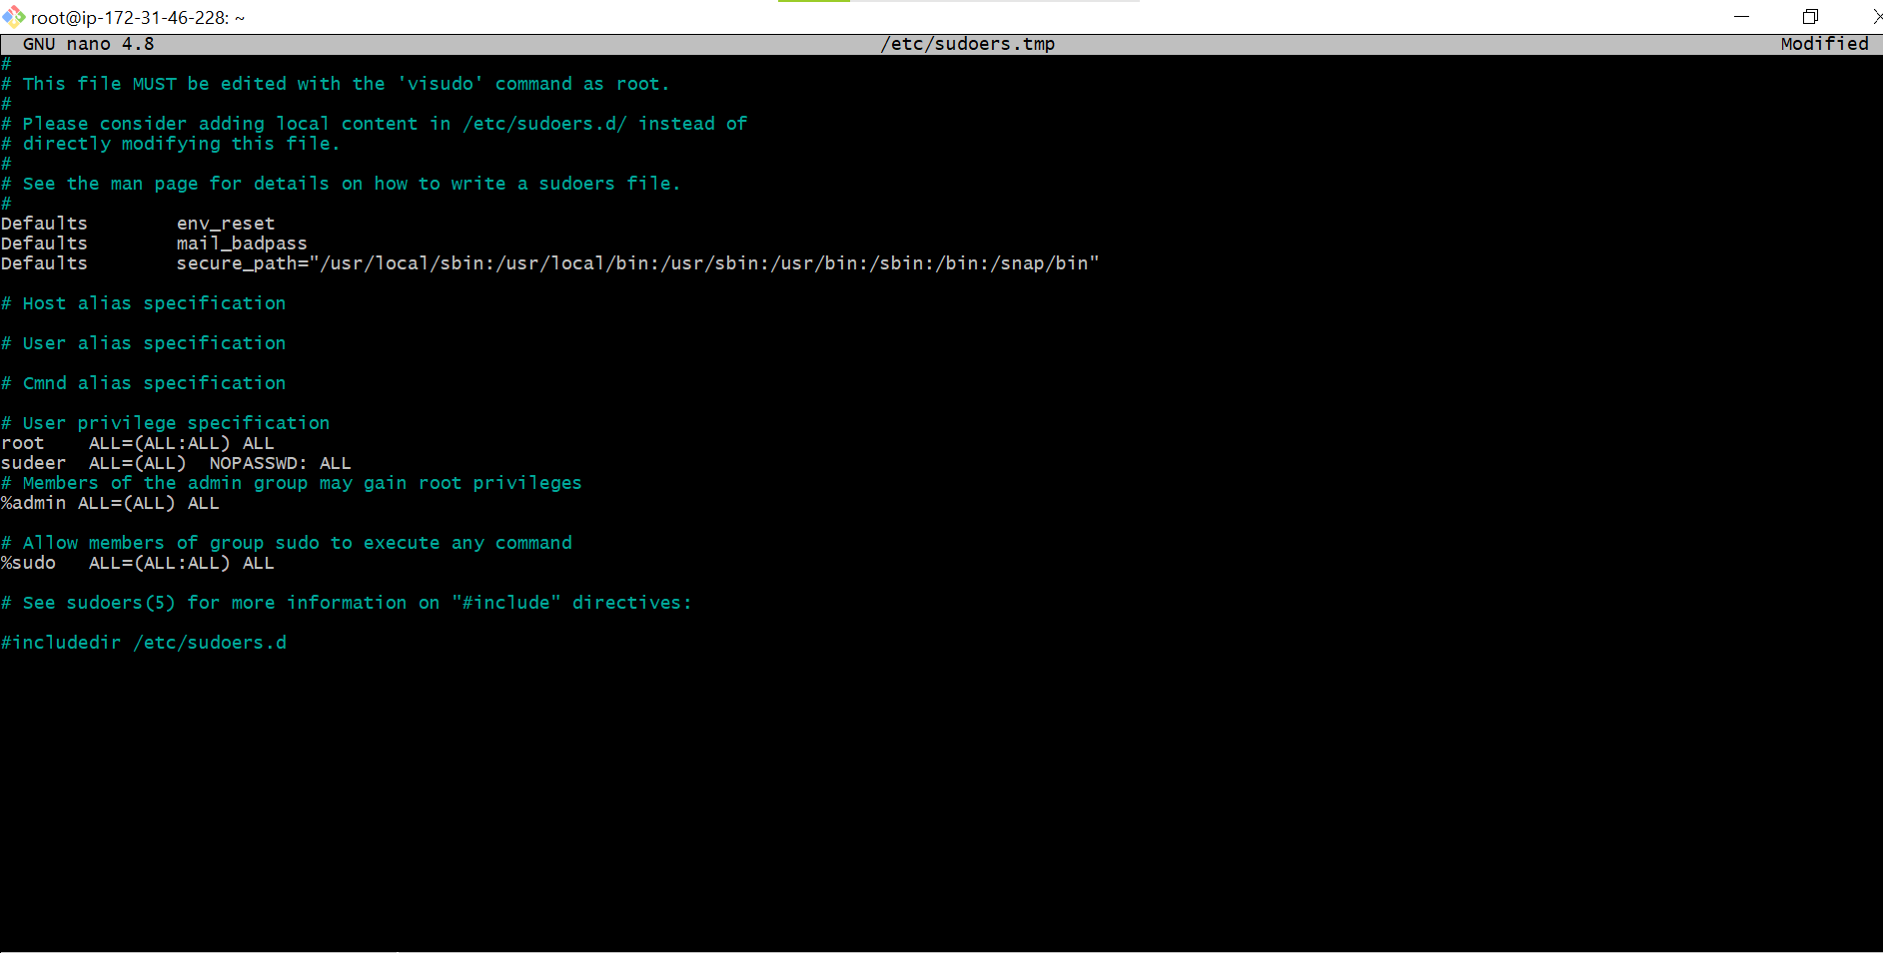

* SUDEER ALL=(ALL) NOPASSWD: ALL
* Ctr+x, press y , press enter

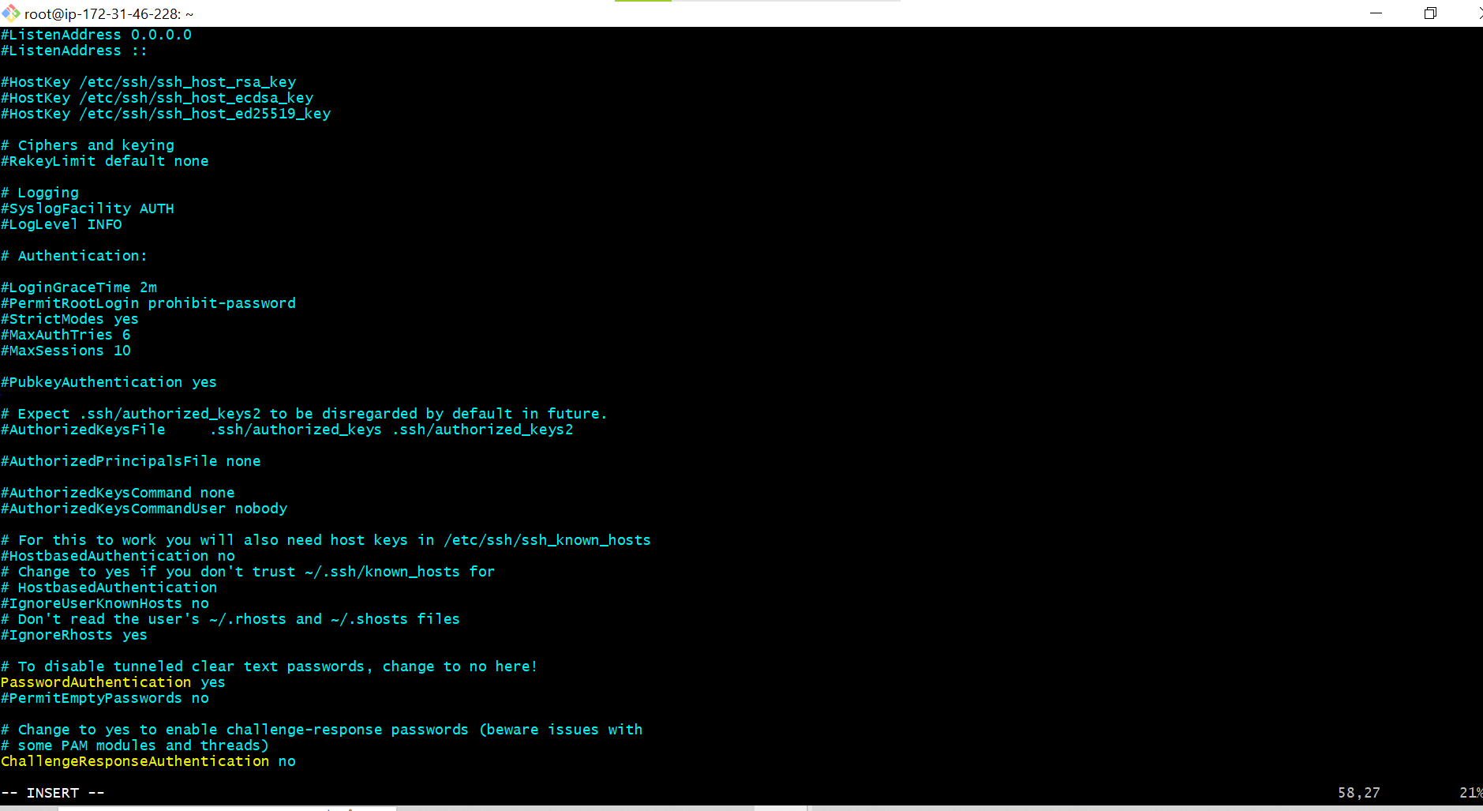

* # vi /etc/ssh/sshd_config( without pem , with passwd)
* Passwordauthentication yes

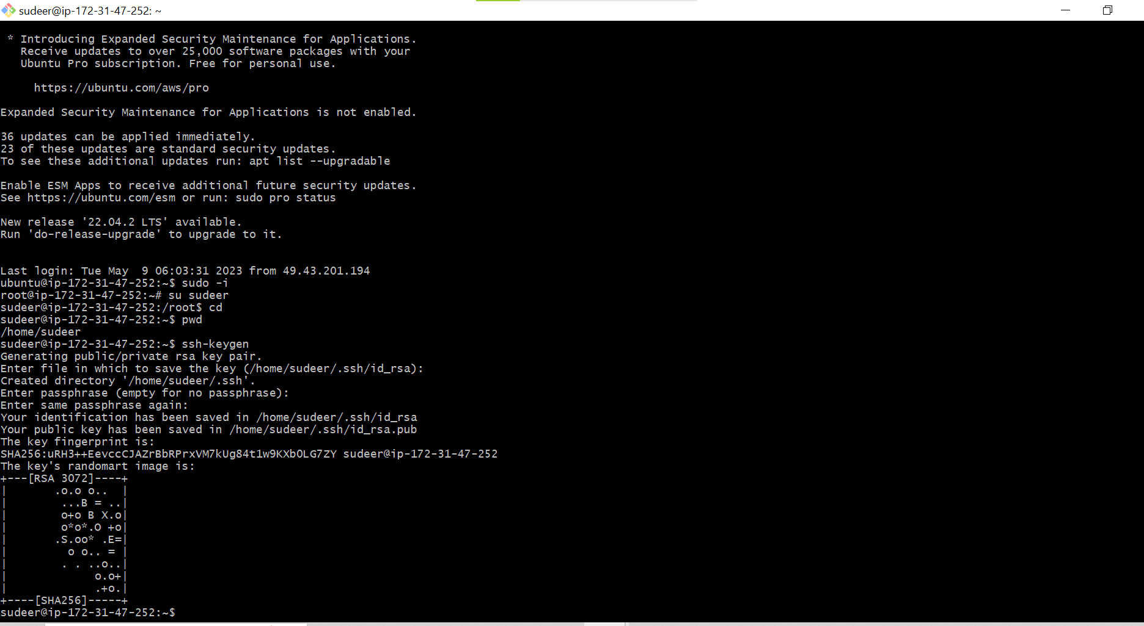

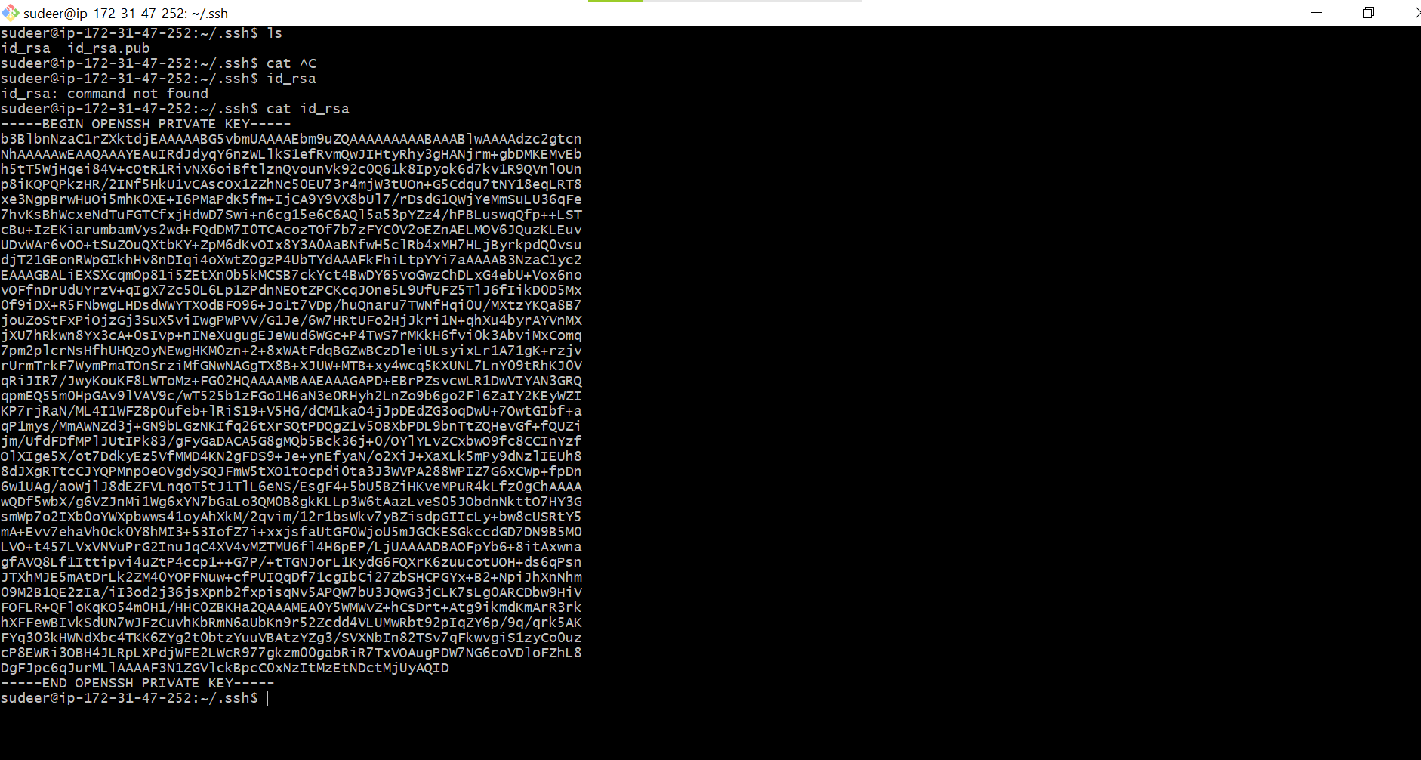

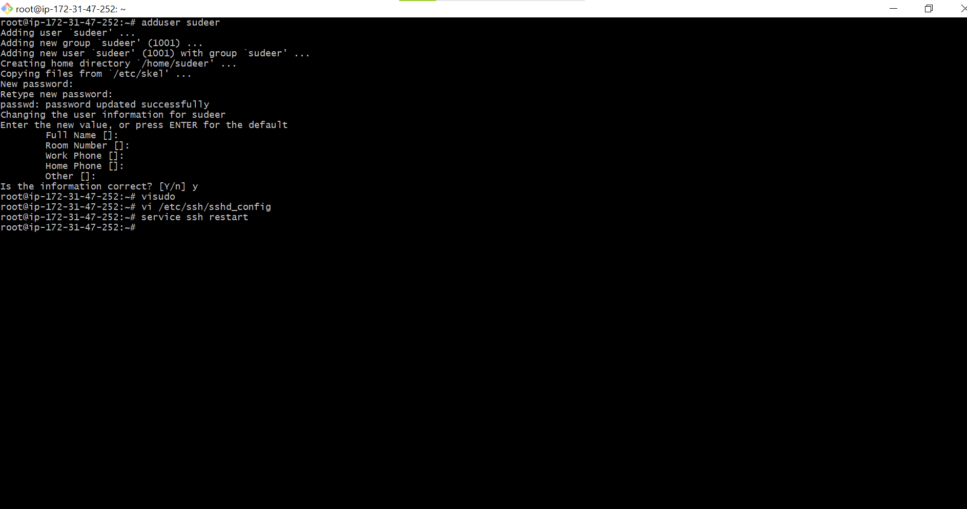

* **CONFIGURE NODES SERVERS**

9) Create an aws server with ubuntu 20. With t2.micro

10) By using git bash and pem file we can getting into server

11) $ sudo -i

12) # apt-get update

13) # adduser maha

14) # visudo

maha ALL=(ALL) NOPASSWD: ALL

Ctr+x, press y , press enter

15) # vi /etc/ssh/sshd_config( without pem , with passwd)

Passwordauthentication yes

:wq!

16) # service ssh restart

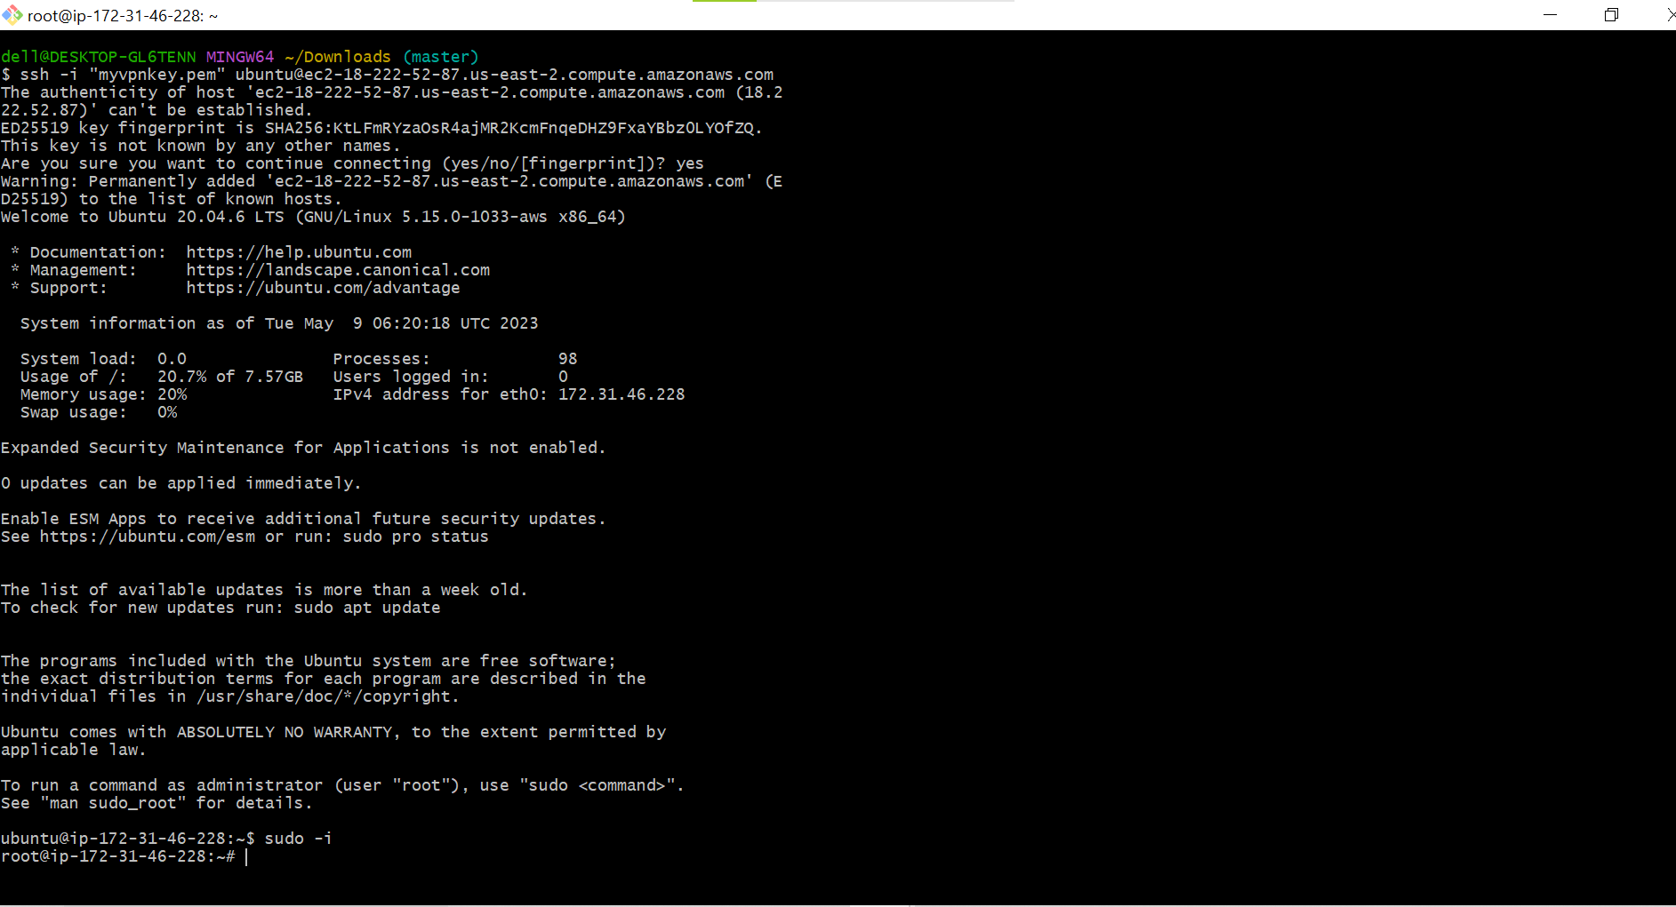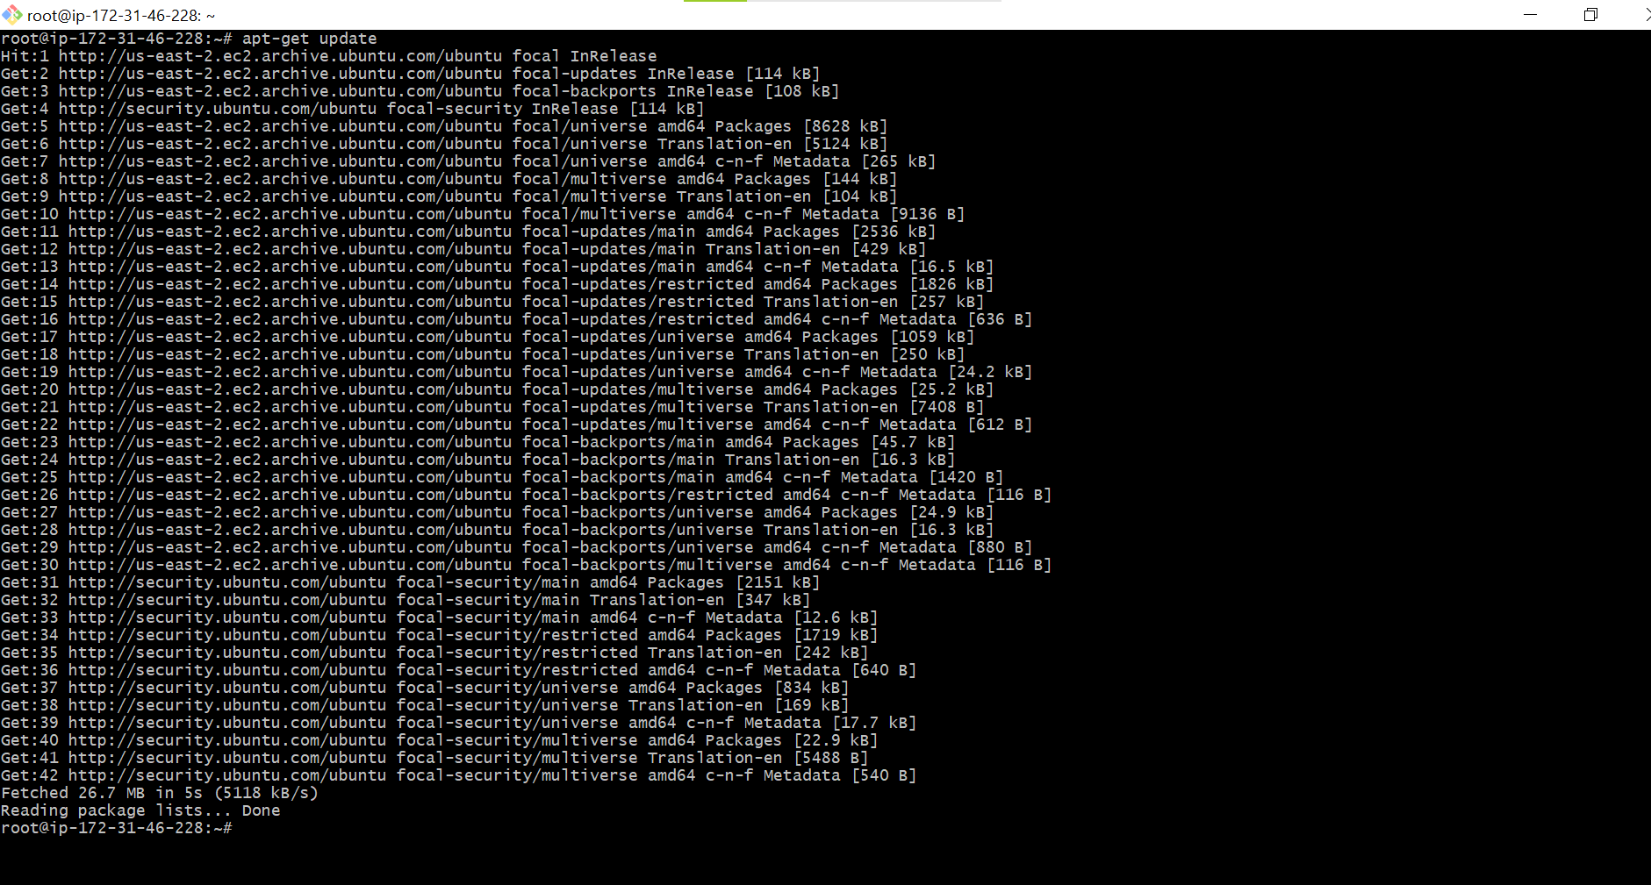

* SUDEER ALL=(ALL) NOPASSWD: ALL
* Ctr+x, press y , press enter



* vi /etc/ssh/sshd_config( without pem , with passwd)
* Passwordauthentication yes



* **Connect from master to node without pem file and password**
* **On master as maha user**

17) $ sudo -i

18) # su maha

19) $cd

20) $ pwd (/home/maha)

21) $ ssh-keygen

22) $ ssh-copy-id < private ip of nodes>

23) $ ssh < private ip of nodes>( without pem file and without passwd) 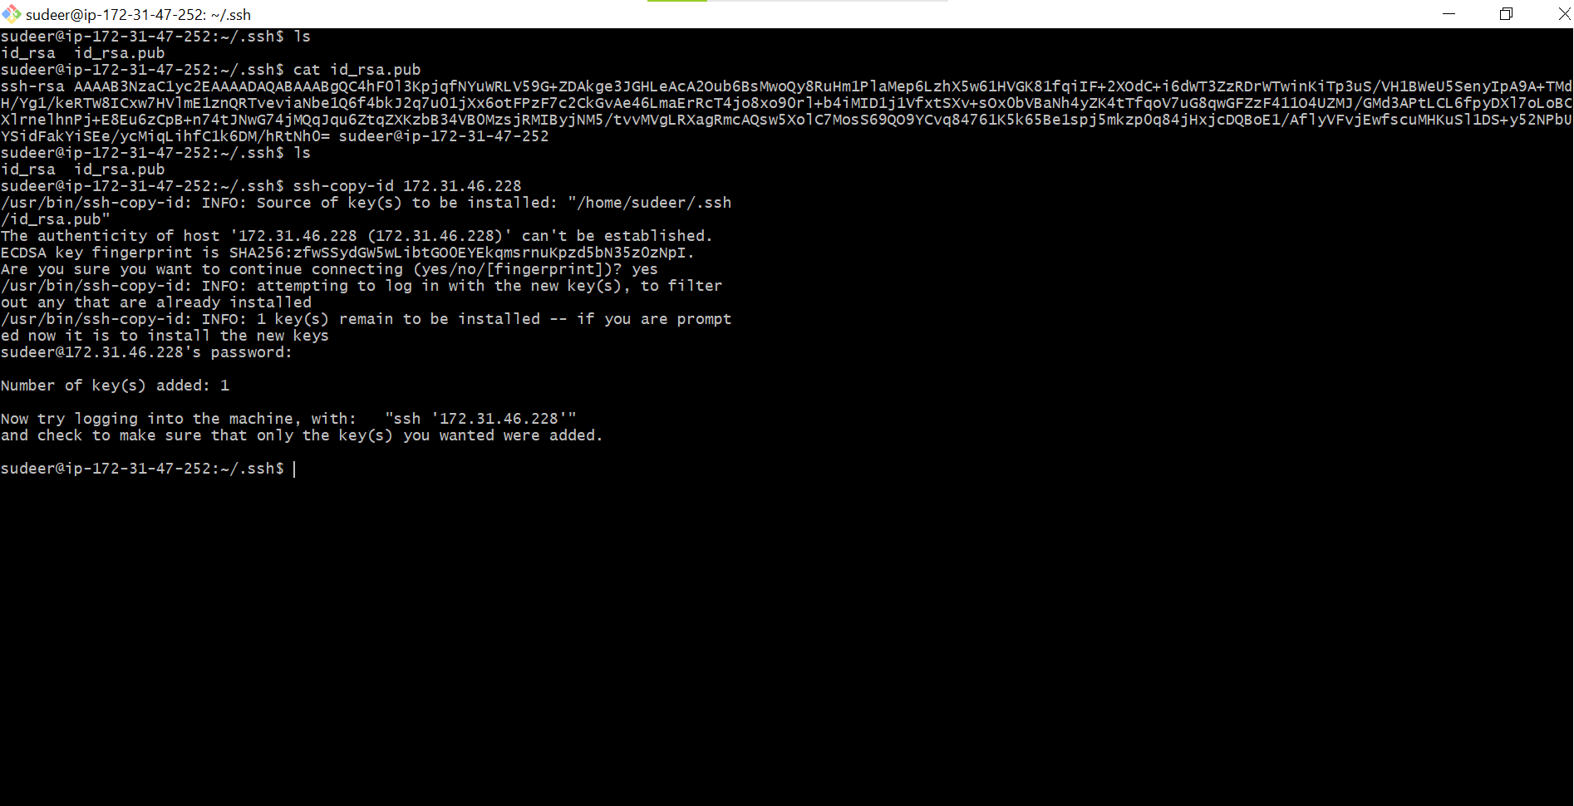

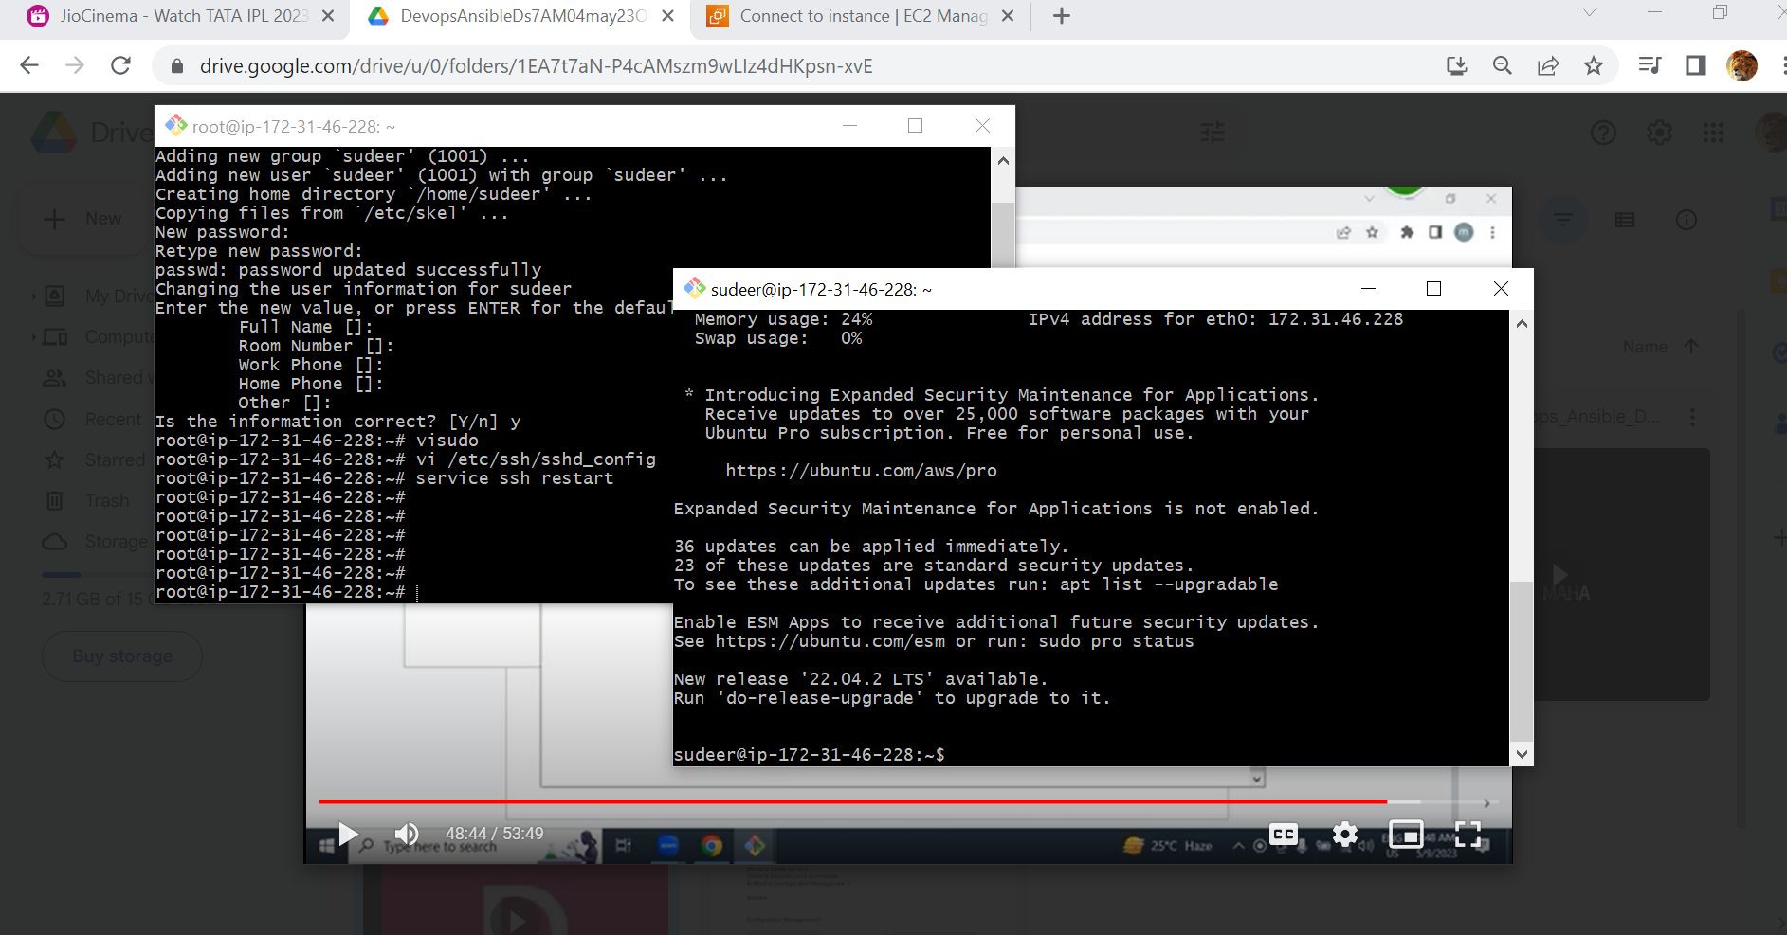

* **HOW TO WRITE A PLAYBOOK AND EXECUTE PLAYBOOK**

Use GIT

1) Create a github account and login

2) Create a token , it just like password

3) Create new Repo on github

4) Install git on your laptop

5) Create a folder and open folder

6) Inside folder open gitbash and execute below git commands ( only once)

echo "# myGitrepo10may23" >> README.md

git init

git add README.md

git commit -m "first commit"

git config --global user.name "maha"

git config --global user.email "maha@gmail.com"

git commit -m "first commit"

git branch -M main

git remote add origin https://github.com/maha4dsvc/myGitrepo10may23.git

git push -u origin main

7) For change

git add -A

git commit -m “comment”

git push

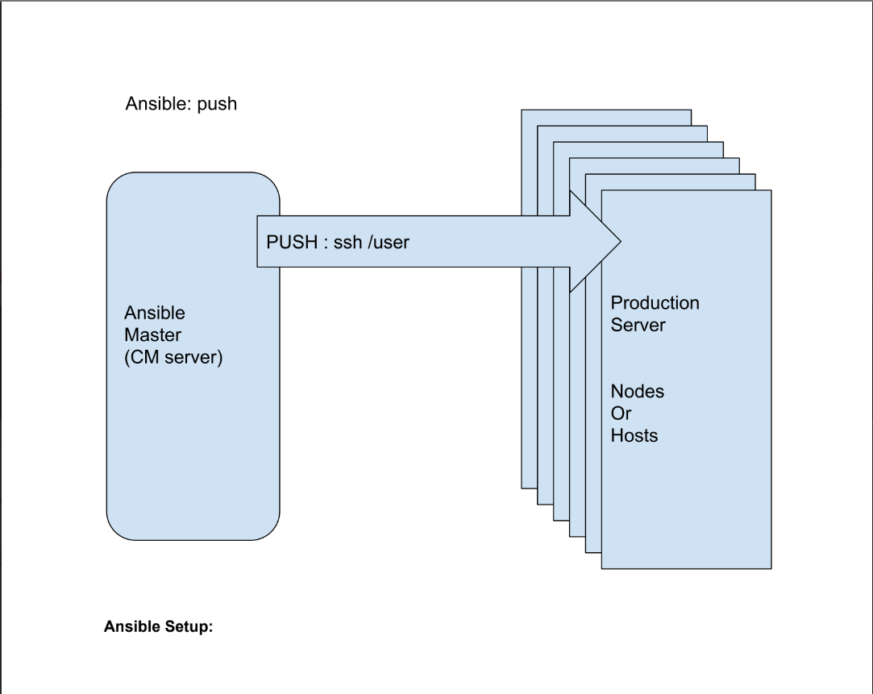

* **Install ansible master and config**

1) Create Aws server with ubuntu 20 with T2.micro

2) After getting server by using ssh , pem file

3) Create a ansible user as maha with passwd

# adduser maha

4) Make ansible user as sudoer

# visudo

maha ALL=(ALL) NOPASSWD: ALL

ctr+x , press y, press enter

5) Password authentication

# vi /etc/ssh/sshd_config

Passwordauthentication yes

:wq!

6) Restart ssh services

# service ssh restart

7) Install ansible

# sudo apt-add-repository ppa:ansible/ansible

#sudo apt update

#sudo apt install ansible

# ansible –version

* **Install ansible nodes and config**

8) Create Aws server with ubuntu 20 with T2.micro

9) After getting server by using ssh , pem file

10) Create a ansible user as maha with passwd

# adduser maha

11) Make ansible user as sudoer

# visudo

maha ALL=(ALL) NOPASSWD: ALL

ctr+x , press y, press enter

12) Password authentication

# vi /etc/ssh/sshd_config

Passwordauthentication yes

:wq!

13) Restart ssh services

# service ssh restart

14) Don’t Install ansible

# sudo apt-add-repository ppa:ansible/ansible

#sudo apt update

#sudo apt install ansible

# ansible –version

* **Connect from ansible master to nodes without pem and password**
* **On Ansible master as MAHA user**

15) $ sudo -i

16) # su maha

17) $ cd

18) $ pwd (/home/maha)

19) $ ssh-keygen

20) $ ssh-copy-id < private ip of ansible nodes>

21) $ vi myhosts

<Private ip of ansible node>

<Private ip of ansible node>

<Private ip of ansible node>

:wq!

22) $ ansible all -i myhosts -m ping

23) Create a playbook and execute

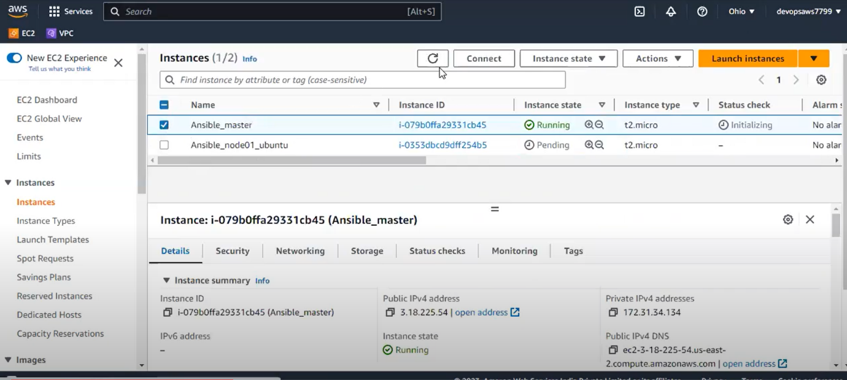

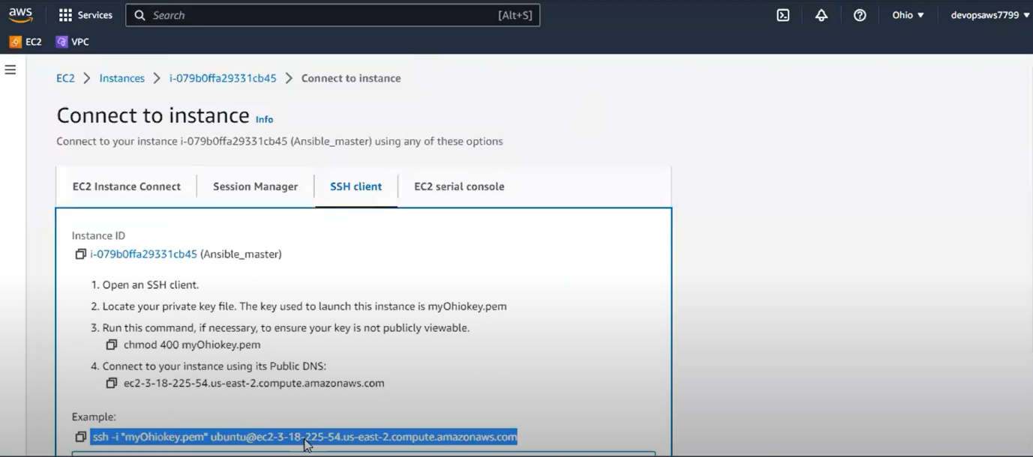

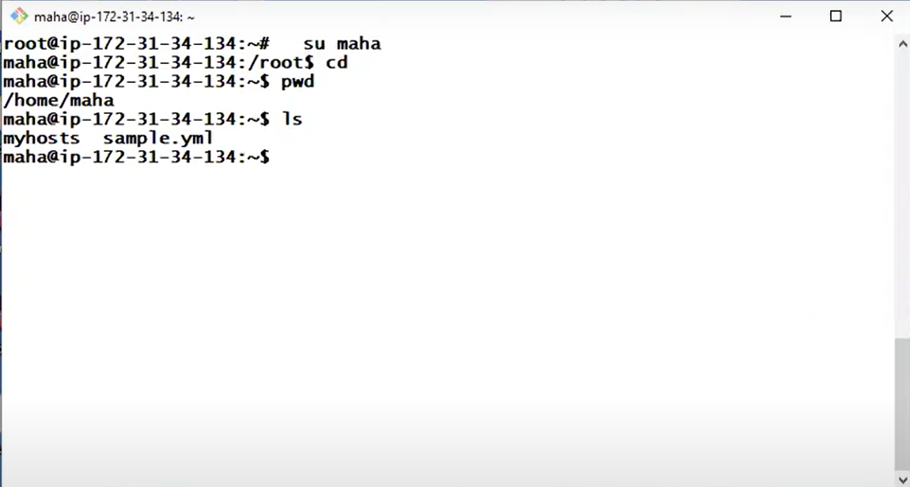

* Here, **myhosts file** is called **inventory file,** myhosts file has no any extension in this file we give private **IP** : 172.31.41.0

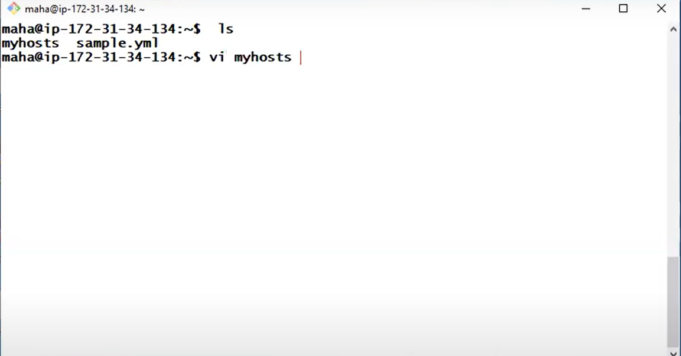

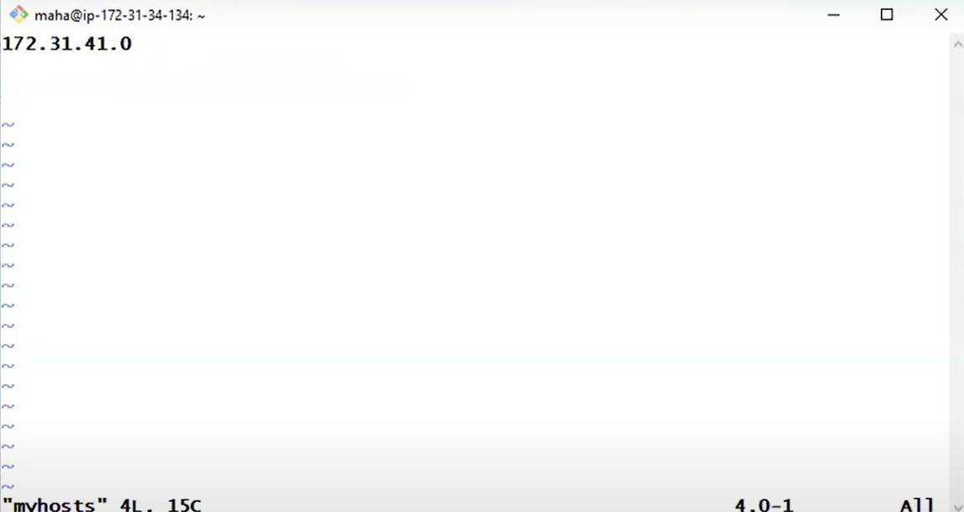

* **-i** called pickup customise **inventory file** after pickup this customise file on top of this inventory file we write a **playbook**

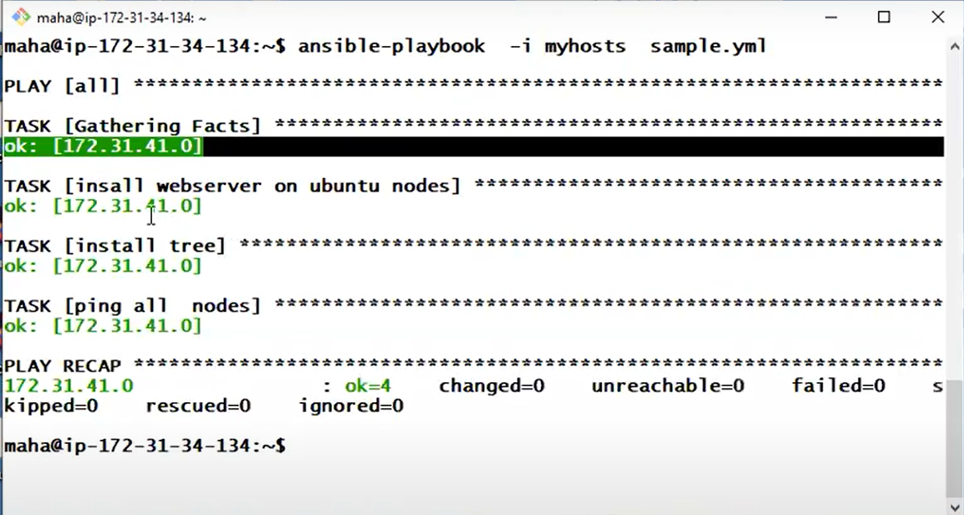

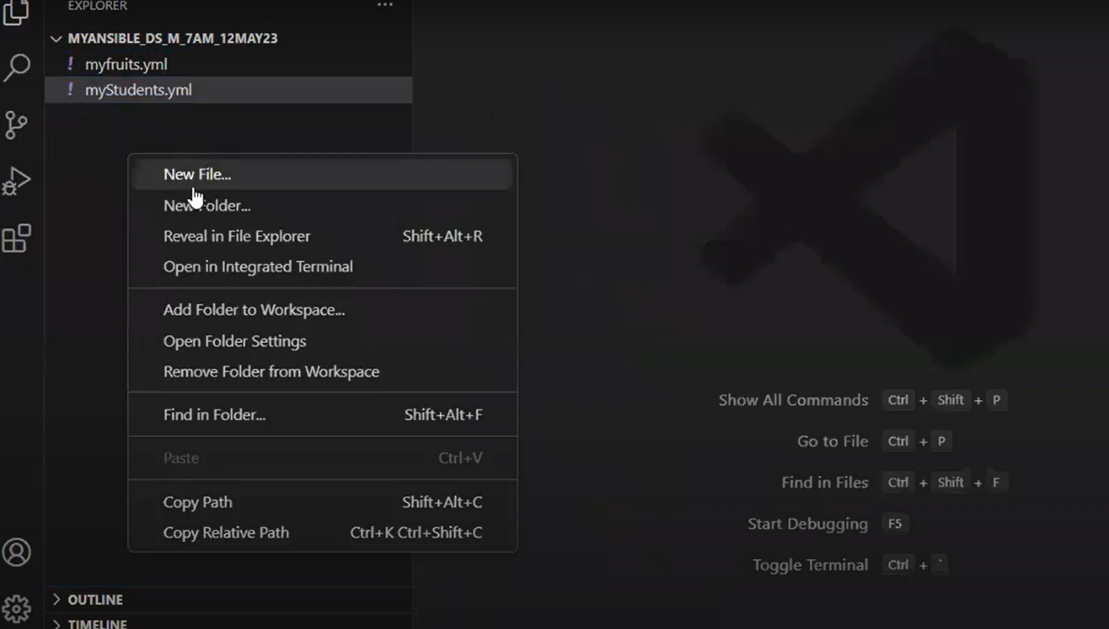

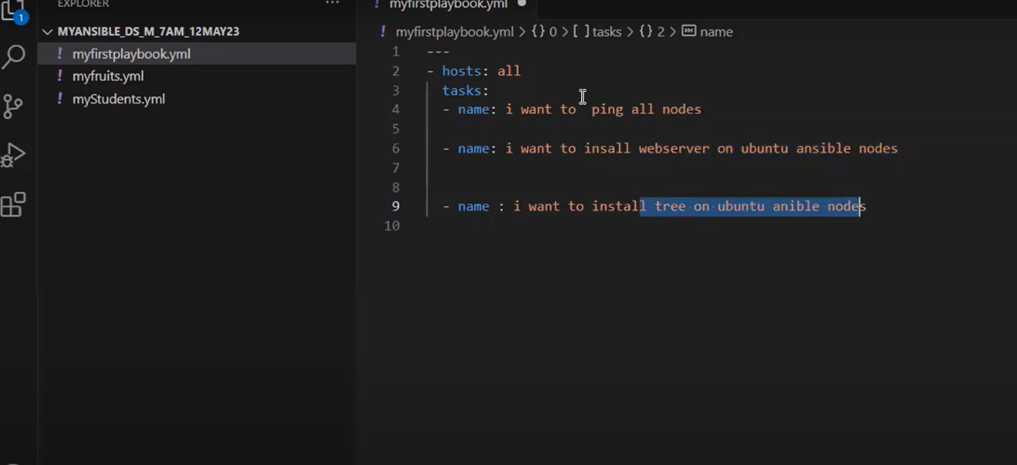

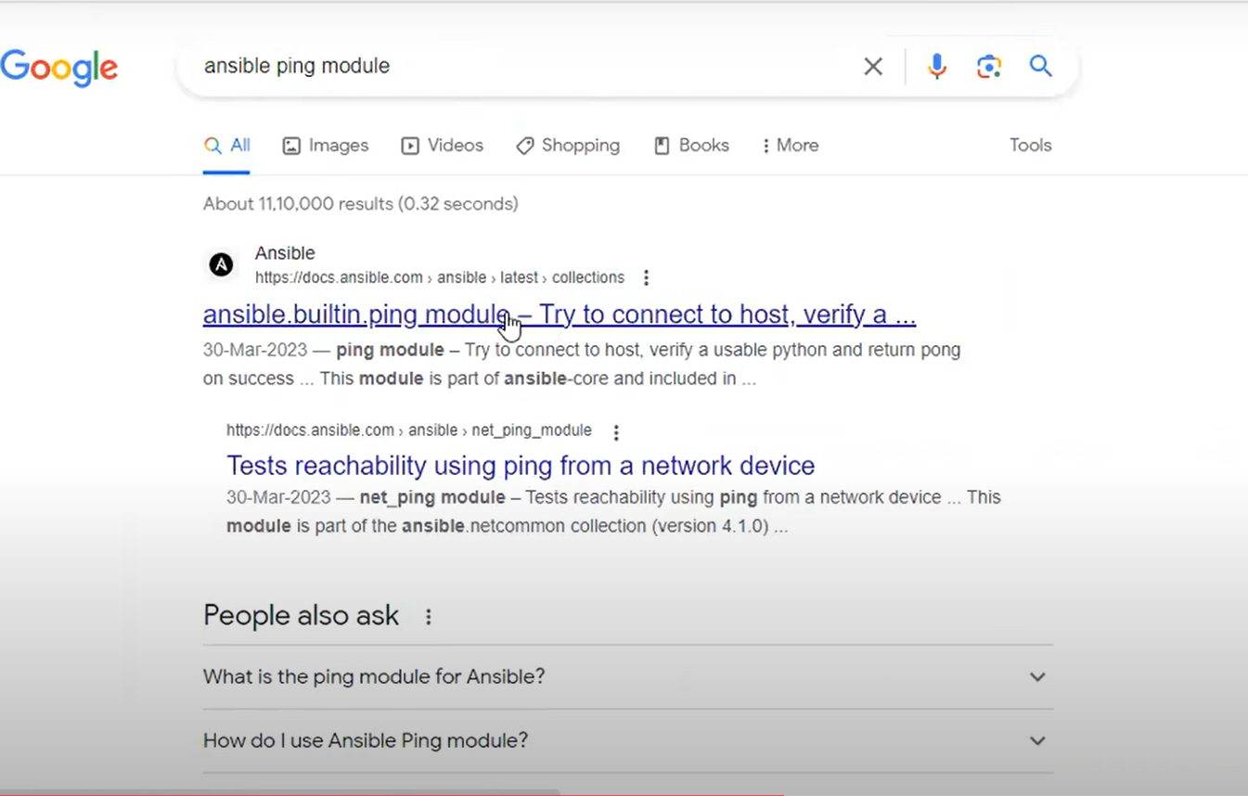

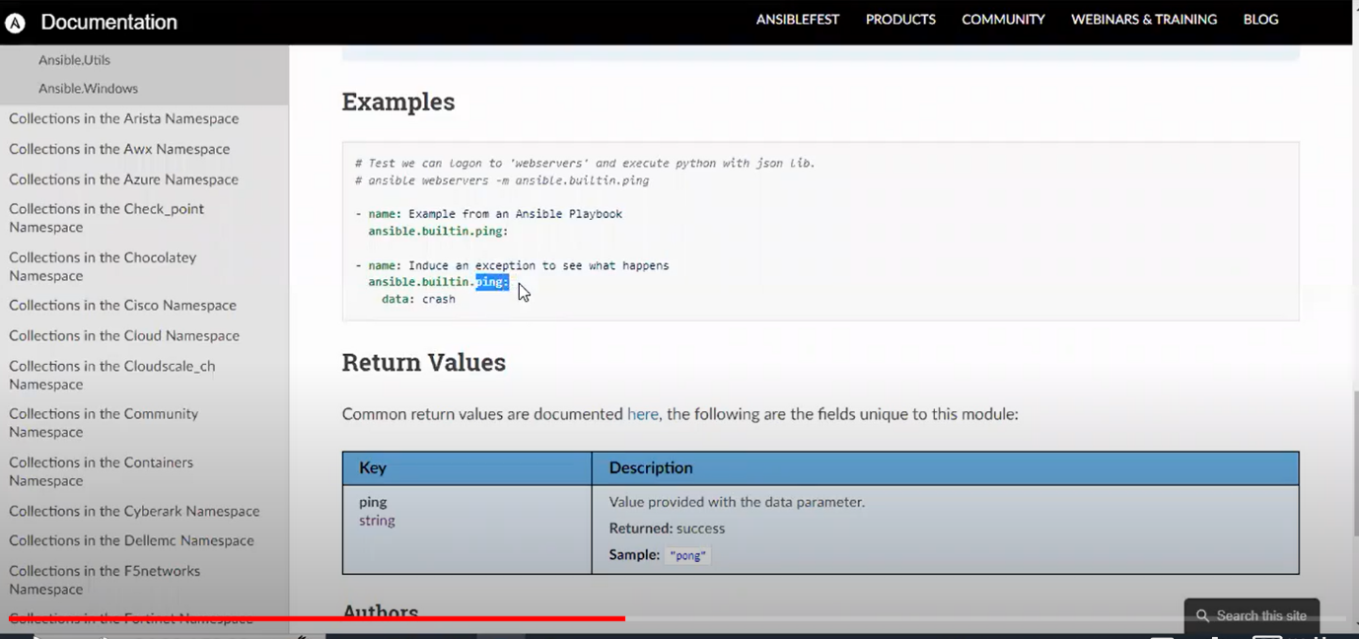





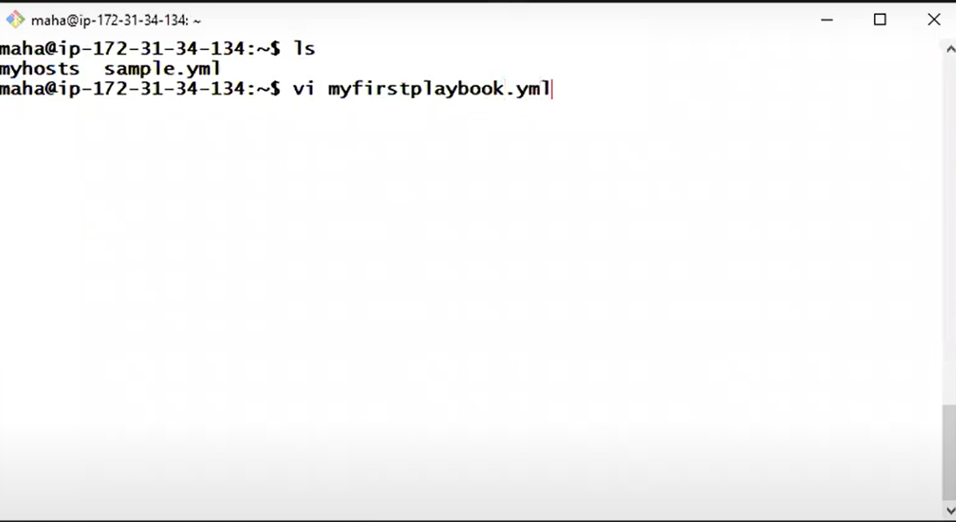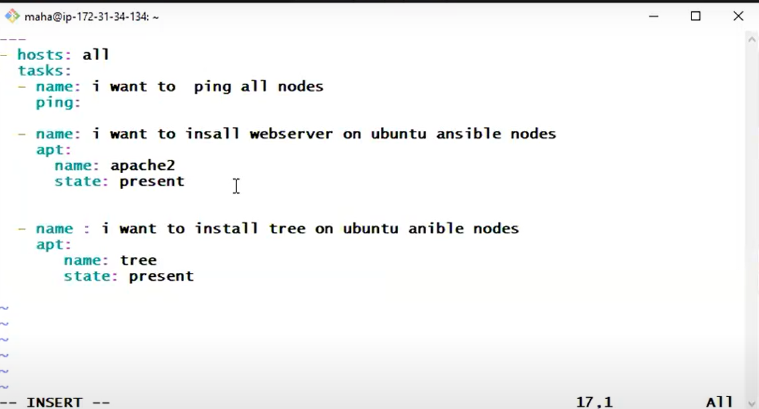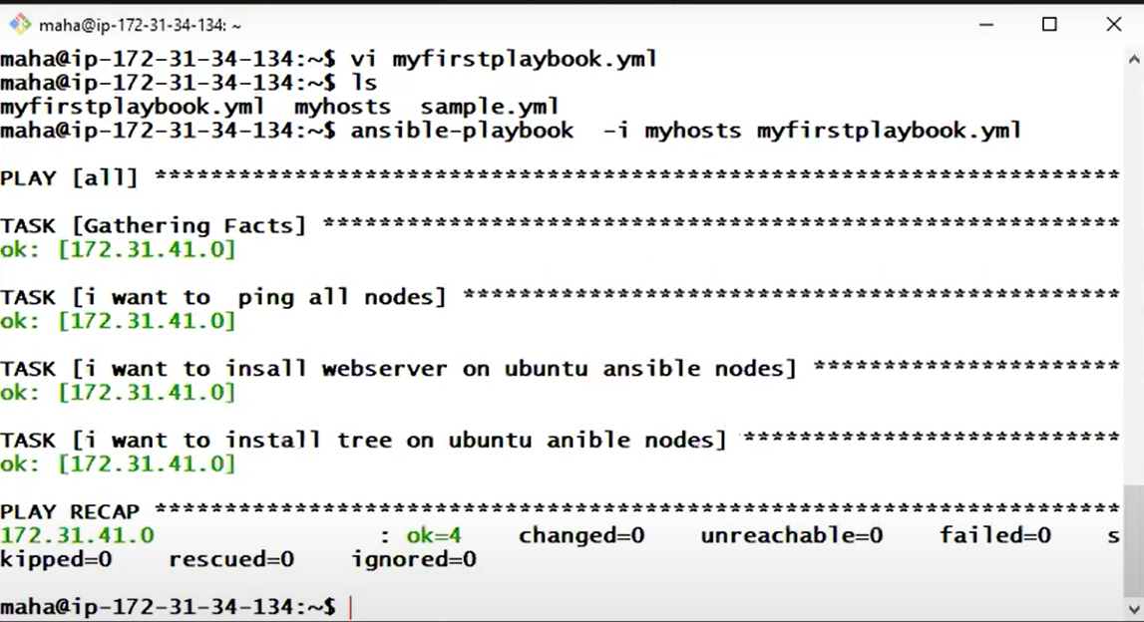

* **How to create a repository in github**

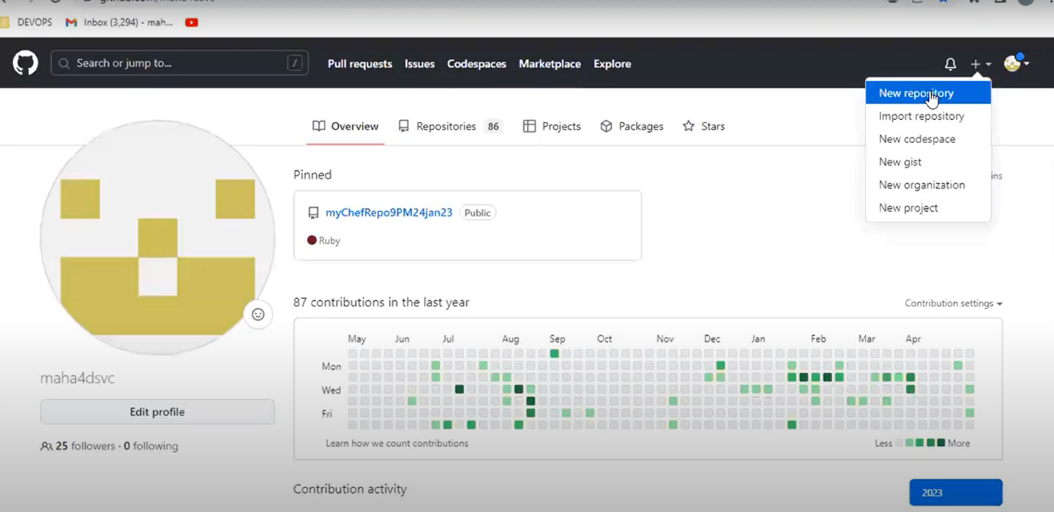

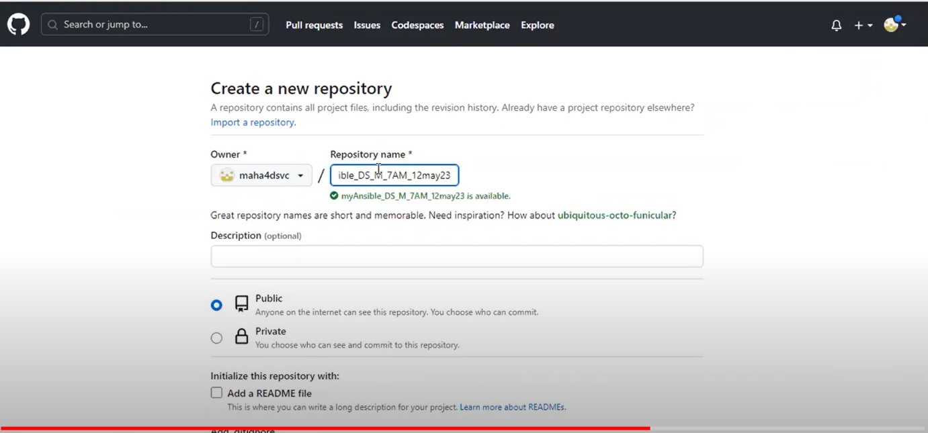

what we have create a folder after that we give repository name

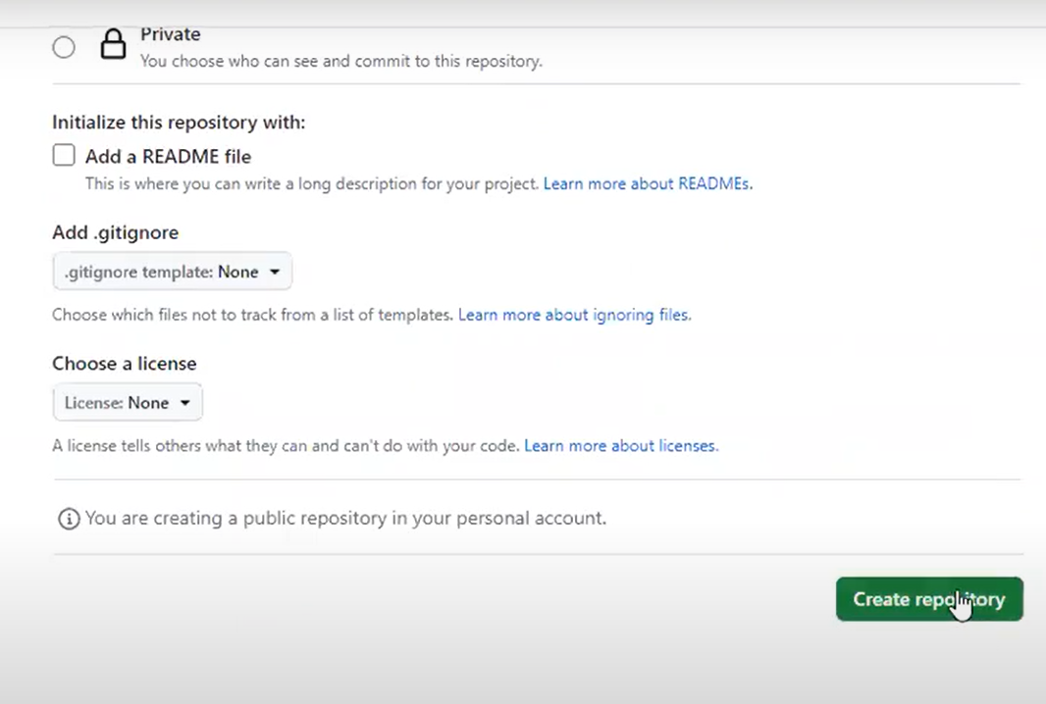

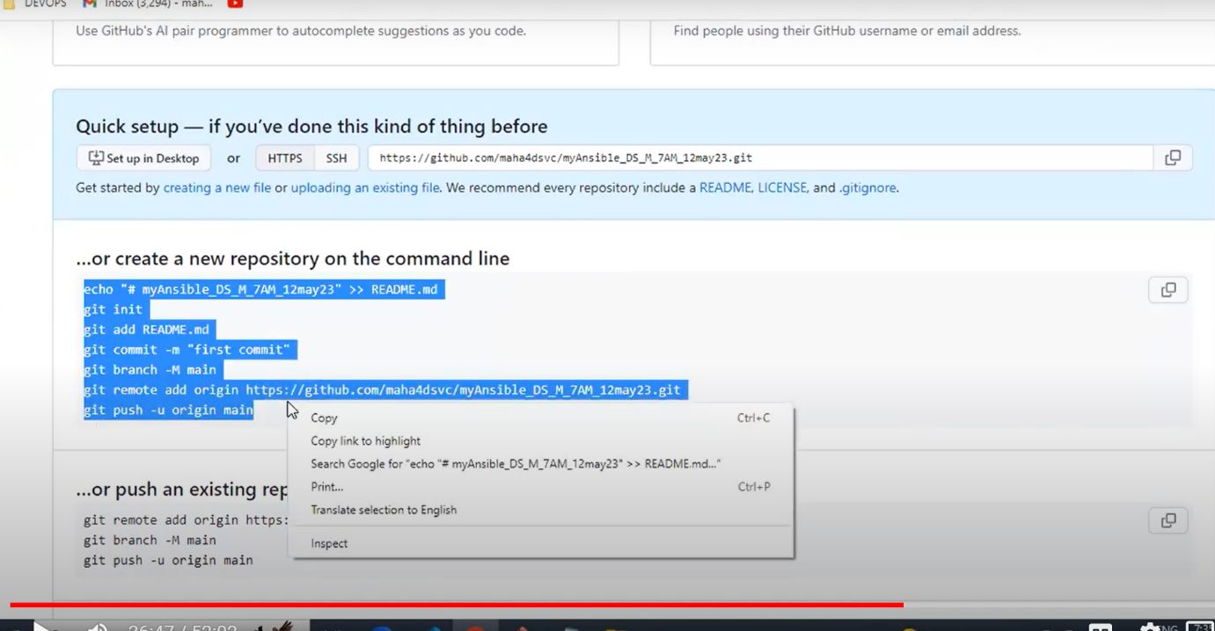

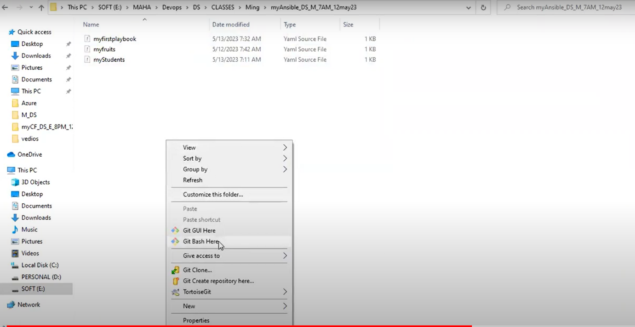

* **Here we have to execute only once**

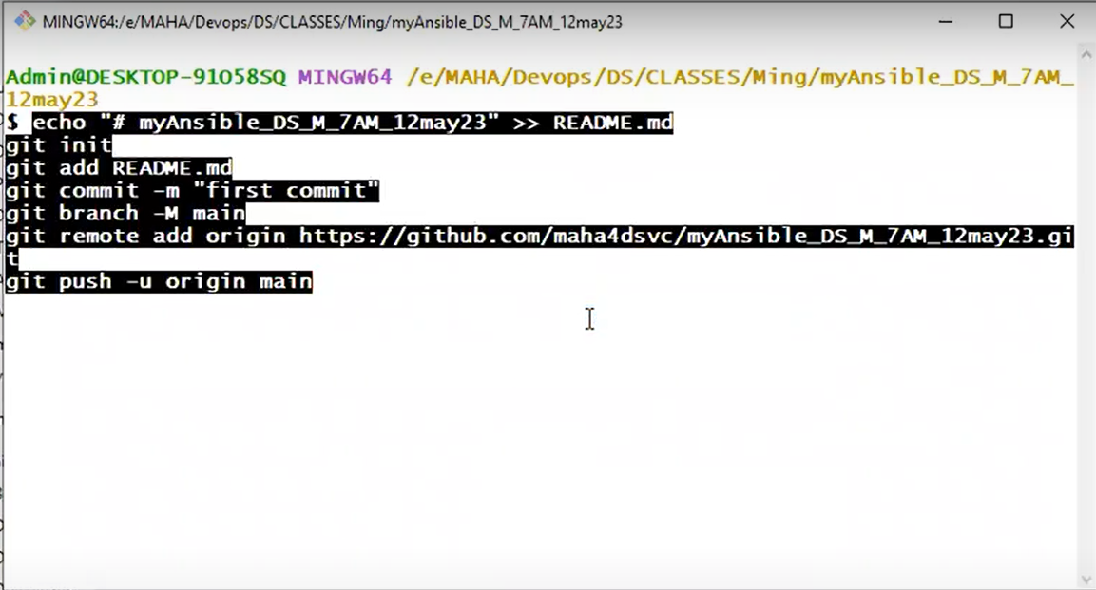

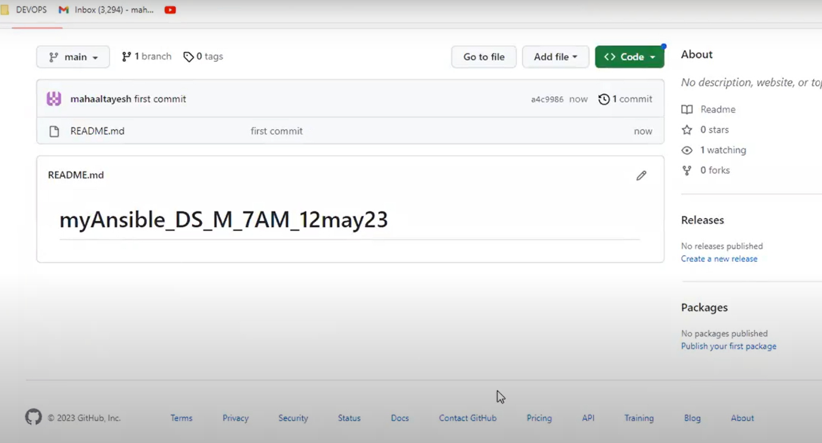

* If we want to change the file we have to give these three commands

1. git add -A
2. git commit -m “ansible”
3. git push

